Directions to Access the Book Online

1. Go to this address

2. Type in your username and password using this format
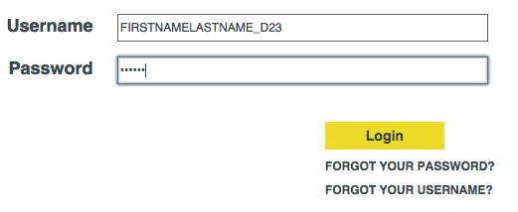
Remember: your password is your initials (lower case) and last 4 digits of your ID number. Example: ma1234

3. Great features:

 | - Self check quizzes for each section AND chapter. These will be available for Extra Credit in certain cases.
 | - Step by step solutions for certain problems within the book.
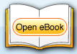 | - Forget your book at school? Good thing you can access the entire book online!
 | - Helpful visuals and videos
 | - Forget your worksheet at school or just want more practice? Come here for more practice resources!

